***Storm and Climate Data Record (SCDR)***

Implementation Plan

Date of record:

Jan 1, 2017 to Dec 1, 2019

Principal Investigator: Cadden Buist

## I. Introduction

### 1.1 Overview and purpose

The purpose of this SCDR or Storm and Crime Data Report is to analyze the data from January 1st of 2017 to December 19th of 2019. In this data set are a series of crimes that occurred during any type of storm within Miami, FL. Our purpose is to use the data set to try and predict the crimes that are occurring during the storm and the rising costs of crimes during storms versus crimes that occur when there is no storm. The Miami Police Department wants its detectives to have the information needed to predict the next string of attacks.

### 1.2 Define why you need data analysis

The reason a data analysis is needed is because there is a data set that has been collected by the Miami Police Department that could lead to the prediction of possible crimes. This information can be useful in slowing down the perpetrators of these crimes which will help limit these attacks on people and property. Without a data analysis the data that has been collected over the last 2 years would be useless at predicting future crimes that are to come when there is storm activity.

## II. Data Preparations

### 2.1 Name data sources

The data source that was used for this data set was one recorded by the Miami Police Department. The data set contains data from crimes that have occurred during storms within the city of Miami between the dates of January 1, 2017, and December 1, 2019. This data also shows the cost of damages occurring during storm activity and when there is no storm activity using the same timeline.

### 2.2 Filter through unnecessary data

The data set that is needing the analysis is the loss of revenue due to the crime that has been committed from our assets lost data and the type of crime activity that is occurring during the storm in our first data set. That would mean that the unnecessary data would be the ID, CrimeEventID, StormEventID, StormActivity, ZoneCityID, Zone, City, and assets lost due to crime when there is no storm. These variables are not the variables being analyzed for the information the detectives of the Miami Police Department want to gather.

### 2.3 Define your parameters

The parameters within the two data sets are the types of crimes that are committed during a storm, what crimes are the most likely to happen during a storm, and damage to assets (thousands of dollars) when a storm is happening or has happened.

### 2.4 Identify measurement priorities

The measurement priorities are whether the crime occurred during a storm or not, the assets lost as in thousands of dollars in this case within the city of Miami. The most important measurement is the assets lost when a storm occurred and when a storm had not occurred. This is because we are attempting to find out how common crimes are when a storm occurs and how much more violent the perpetrator gets when a storm is happening currently versus when a storm is not happening.

### 2.5 Ensure collected data fits the need

The data that the Miami Police Department has collected does fit the need for the information that is needed for this data analysis. As in the instructions the important data set is data set that shows the assets in thousands of dollars lost due to crimes during a storm and not during a storm. The data analysis that will analyze this data has the required information to proceed with the data analyst.

## 

## III. Data Analysis

### 3.1 Identify scripts used

The scripts that were used for this data set was 2 package installs one for the tframe and the other for the tfplot or the TensorFlow plot. A library was then created for the tframe and tfplot packages and then the crime storm data was pulled from the data set. Afterwards the x and z axes were established and finally the tfplot or TensorFlow plot was created and the new plot was given labels to help identify the plot.

### 3.2 Run the scripts to analyze the data and validate the output

After running the scripts a couple of times, I was given the TensorFlow plot to begin the conclusion portion of my analysis over the data set given to me by the Miami Police Department where I will do a deeper dive.

## IV. Drawing Conclusions

### 4.1 Present the results of the analysis to stakeholders

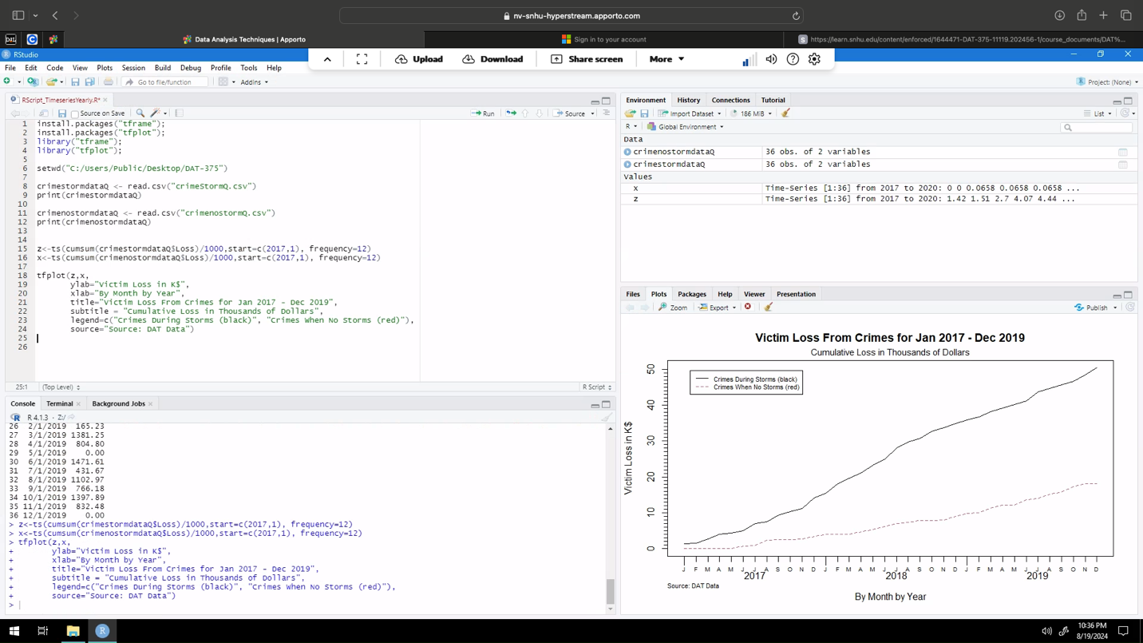

As we can see from our scripts and most importantly our plot crimes that occur when there is a storm tend to take a bigger toll on assets in thousands of dollars than crimes that take place when there is no storm. This does leave out plenty of information, but it does let us know that crimes during a storm is more likely to cost the victim more assets in money than crimes protrude when there is not an active storm.

### 4.2 Determine whether the problem was addressed, including any challenges and limitations

The problem that was presented has been addressed within this SCDR which was to provide the detectives of the Miami Police Department with information pertaining to crimes during storms examining the rising cost of those crimes. This was addressed within this SCDR proficiently. Some challenges and limitations I see is the fact that this information will not be as useful for predicting the next string of crimes with the next storm. This is due to the lack of variables needed to predict a likely location, crime, and time of storm i.e. if it’s the beginning middle or end of the storm.

### 4.3 Report potential new findings

New finding that we can include in this data set are the types of crimes being committed or how violent the crime is taking place or if it was done to property or a person. We could also add zones within Miami to see what zones are the most targeted when storms are occurring. Finally, we can use time of day the crime took place or how far into the storm the crime occurred in. These variables I believe would give the Miami Police Department the right information needed for them to be able to prevent these crimes from happening or at least lessen the damage caused by these crimes during a storm.

**References**

* Larose, D., Larose, C.(2015). Data Mining and Predictive Analytics, 2nd edition. John Wiley and Sons, Inc. Chapter 3.
* Data Visualization: What it is and why we use it. Analytics and mobility. <https://web.archive.org/web/20191107194208/https://www.microstrategy.com/us/resources/introductory-guides/data-visualization-what-it-is-and-why-we-use-it>